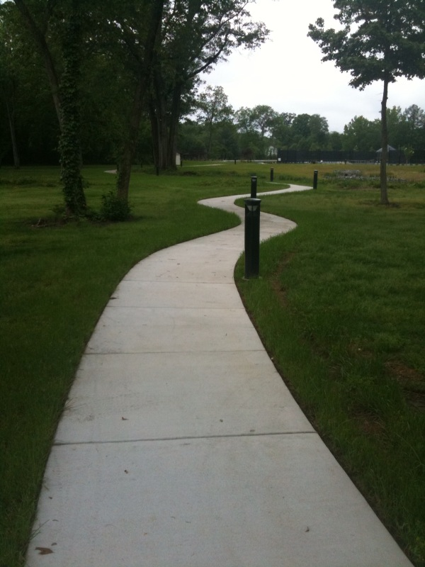

Yes we'll walk with a walk that is measured and slow,  
And we'll go where the chalk-white arrows go,  
For the children, they mark, and the children, they know  
The place where the sidewalk ends.

**Where the Sidewalk Ends by Shel Silverstein**

There is a place where the sidewalk ends  
And before the street begins,  
And there the grass grows soft and white,  
And there the sun burns crimson bright,  
And there the moon-bird rests from his flight  
To cool in the peppermint wind.

Let us leave this place where the smoke blows black  
And the dark street winds and bends.  
Past the pits where the asphalt flowers grow  
We shall walk with a walk that is measured and slow,  
And watch where the chalk-white arrows go  
To the place where the sidewalk ends.

**Heaven Is What I Cannot Reach!**

**by Emily Dickinson**



Heaven is what I cannot reach!  
The apple on the tree,  
Provided it do hopelss hang,  
That "heaven" is, to me.

The color on the cruising cloud,  
The interdicted ground  
Behind the hill, the house behind, --  
There Paradise is found!



***Poetry***

Poetry is boring

Poetry is bland

Poetry is something that is definitely not grand

Poetry is lame

Poetry is dumb

Poetry sometimes makes me want to cut off a thumb

Poetry is odd

Poetry is a bore

Poetry makes us young people snore

Although we snore

we know it’s a chore

and we must do it to get a good score

C:\Documents and Settings\User\Local Settings\Temporary Internet Files\Content.IE5\NTLVK0E4\MC900088568[1].wmf

**Similarities**

* Both famous poets
* Wrote hundreds of poems
* Had children

**Heaven Is What I Cannot Reach, By Emily Dickinson**

* The poem doesn’t rhyme
* Sounds like something you would read in English class
* Born in Amherst
* Had three children

**Where the Sidewalk Ends, By Shel Silverstein**

* The poem rhymes
* Sounds less professional
* Born in Chicago
* Had two kids

C:\Documents and Settings\User\Local Settings\Temporary Internet Files\Content.IE5\NTLVK0E4\MC900030262[1].wmf

**A Dream**

**by Edgar Allan Poe**

In visions of the dark night   
I have dreamed of joy departed  
But a waking dream of life and light   
Hath left me broken-hearted.

Ah! what is not a dream by day   
To him whose eyes are cast   
On things around him with a ray   
Turned back upon the past?

That holy dream - that holy dream,   
While all the world were chiding,   
Hath cheered me as a lovely beam   
A lonely spirit guiding.

What though that light, thro' storm and night,   
So trembled from afar  
What could there be more purely bright   
In Truth's day-star?